**ART AND PROJECT REPORT**

**TRUCK ART**

My theme for the course, **techniques and process**, is truck art. Pakistan's 'truck art' has become a globally recognized 'genre.' Truck art is a prominent style of regional décor in South Asia, where the concept of adorning trucks (as well as lorries and even rickshaws) with intricate floral patterns and poetic calligraphy has blossomed in the most vibrant and original way.

Reflecting the nation’s rich culture and heritage, this popular artwork is appealingly decorated with vibrant hues and intricate details. From flowers and peacocks to slogans and Urdu poetry, its each eye-catching motif has been recognized far and wide. This form of art is commonly captured at Pakistani highways, on trucks, buses and rickshaws

Here are a few images of how beautifully truck art can be used in different ways

2. 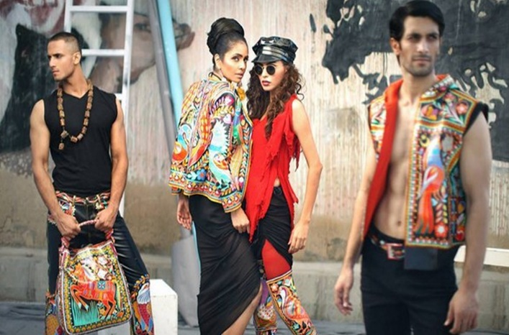

3. 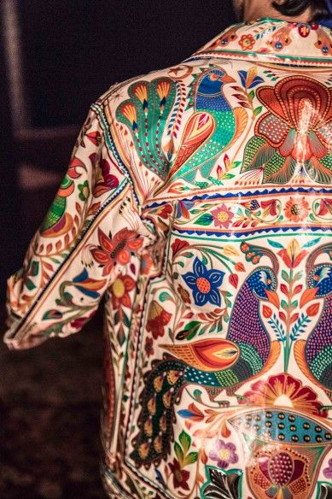

“The evolution of portraiture in Pakistani truck painting is indicative of strong global influences and local folk elements coming together.” Farah Ali, Georgia State University 2021

After a lot of research, the reason I elected truck art for my theme is that I wanted something vibrant and beautiful at the same time. It has a lot of elements in it which provides me many options. It looks vivacious and catches your eye instantly. Also, if you get it printed on the fabric, you can style it in every way. Truck art can go with eastern as well as western which means most of the people would opt for my garments, so it does not restrict me to a specific type. I am glad I chose this theme because it literally covers all the required aspects.

**BIBLIOGRAPHY**

1. <https://i.pinimg.com/originals/69/07/74/690774fe850894829ebae13bedd043d6.jpg>
2. <https://www.brandsynario.com/wp-content/uploads/clothes-truck-art.jpg>
3. <https://i.pinimg.com/originals/25/1f/22/251f2221c217b145477f76bb4a534840.jpg>